Ideation Phase
Define the Problem Statements

Date | 17 February 2026
Team ID | LTVIP2026TMIDS39366
Project Name | Heritage Treasures: An In-Depth Analysis of UNESCO World Heritage Sites (2019)
Maximum Marks | 8 Marks

Problem Statement Template:
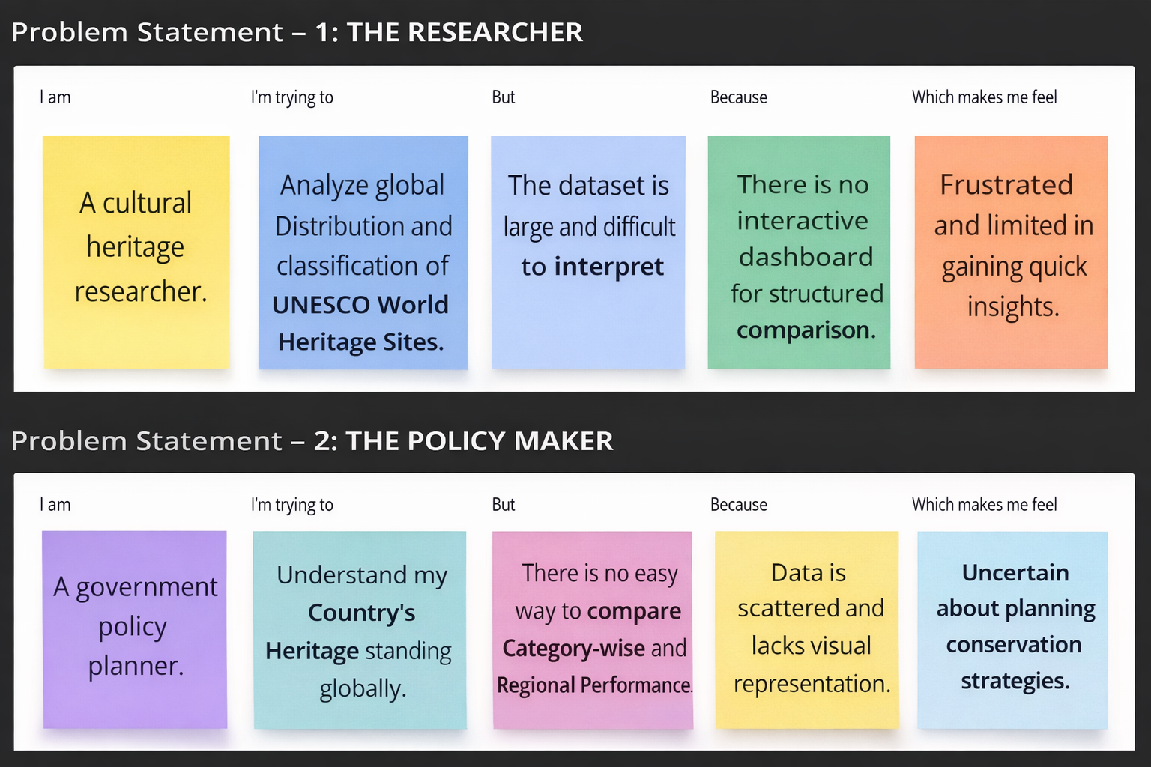

Section | Problem Statement – 1: THE RESEARCHER | Problem Statement – 2: THE POLICY MAKER
I am | A cultural heritage researcher. | A government policy planner.
I’m trying to | Analyze global distribution and classification of UNESCO World Heritage Sites. | Understand my country's heritage standing globally.
But | The dataset is large and difficult to interpret in raw format. | There is no easy way to compare category-wise and regional performance.
Because | There is no interactive dashboard for structured comparison. | Data is scattered and lacks visual representation.
Which makes me feel | Frustrated and limited in gaining quick insights. | Uncertain about planning conservation strategies.

